A1316-AM,S-Peru-Paracas-Figurine-Terracotta-Black Slip-800-100 BCE

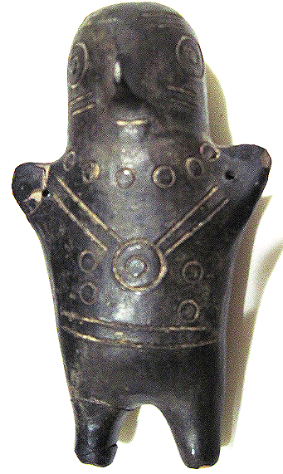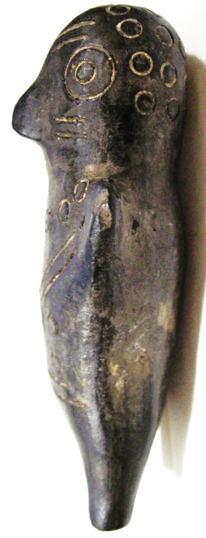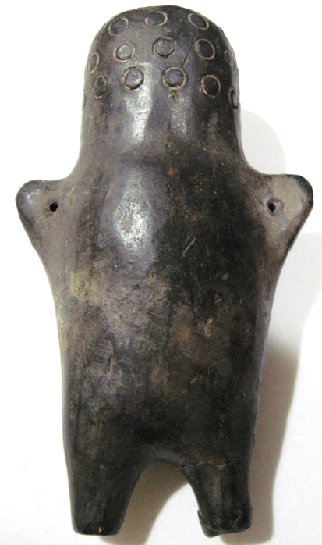

Figs. 1-3. AM,S-Peru-Paracas-Figurine-Terracotta-Black Slip-800-100 BCE

**Case No.: 9**

**Accession No. A1316**

**Formal Label:** AM,S-Peru-Paracas-Figurine-Terracotta-Black Slip-800-100 BCE

**Display Description:**

This is an unusual Paracas black slip terra cotta figurine. It has holes in each of its extyended upper appendages that indicates it was suspended either as an amulet or as a toy. The Paracas culture was an Andean society existing between approximately 800 BCE and 100 BCE, with an extensive knowledge of irrigation and water management and that made significant contributions in the textile arts. It was located in what today is the Ica Region of Peru. Most information about the lives of the Paracas people comes from excavations at the large seaside Paracas site on the Paracas Peninsula, first investigated by the Peruvian archaeologist, Julio Tello, in the 1920s.

The *Paracas Cavernas* are shaft tombs set into the top of Cerro Colorado, each containing multiple burials. There is evidence that over the centuries when the culture thrived, these tombs were reused. In some cases, the heads of the deceased were taken out, apparently for rituals, and later reburied. The associated ceramics include incised polychrome, "negative" resist decoration, and other wares of the Paracas tradition. The associated textiles include many complex weave structures as well as elaborate plaiting and knotting techniques.

**LC Classification:**

**Date or Time Horizon:**

**Geographical Area:**

**Map:**

**GPS coordinates:**

**Cultural Affiliation:**

**Media:**

**Dimensions:**

**Weight:**

**Condition:**

**Provenance:**

**Discussion:**

**References:**

Paul, Anne. 1991. Paracas Art and Architecture: Object and Context in South Coastal Peru. Ames: University Of Iowa Press.